**INDEX**

1. **INTRODUCTION………………………………………………………………………………...2**
2. **PROJECT INFORMATION…………………………………………………………………….2**
3. **ASSUMPTIONS…………………………………………………………………………………..3**
4. **MATHEMATICAL MODEL……………………………………………………………………3**
5. **COMPUTER IMPLEMENTATION……………………………………………………………6**
6. **RESULTS OF IMPLEMENTATION…………………………………………………………...7**
7. **CONCLUSIONS, RECOMMENDATIONS, AND FUTURE WORK………………………..7**
8. **INTRODUCTION**

This project is designed to optimize the class schedule for Fall 2021 for the Entomology Department at Mavericks University. We were given the necessary data for this task in the form of an excel file. This excel file contained information that included the course names and credit hours, the classrooms available, the professors and their workload for the coming semester, and much more. Included within the excel was also a preference list that we needed to use to generate a list of preferences for each professor according to their qualifications. We as a group was also tasked with the development and implementation of two unique rules that would shape the outcome. All data was handling was performed through Python with no changes to the original data. This project was completed with the idea that any department would be able to use the code to solve their assignment problems so long as they provide their data in the same structure.

The remainder of the report is as follows. Section 2 describes the information relevant to the class schedule of Fall 2021 for the Entomology Department at Mavericks University. Section 3 discusses the relevant assumptions made while addressing the problem. Section 4 explains the mathematical model created to solve the issue. Section 5 provides the computer implementation as well as a detailed explanation of our implementation. Section 6 will discuss the results of the implementation. Finally, Section 7 concludes the report, provides a recommendation and presents the topics for potential work.

1. **PROJECT INFORMATION**

This section presents the relevant information of the project. By analyzing the data provided within the excel file, we can find sections labeled: Colleges and Departments, Course Catalog, Professors, Qualification, Courses Offered Fall 2021, and Classrooms. The section labeled Colleges and Departments contains the college, college code, department, and department code. The next section contained all relevant information regarding the courses in the College of Agriculture. It contained the course number, course name, and credit hours per course. Credit hours are important because it lists how often a course is presented a week. For reference, one credit hour is worth fifty minutes. The next section, Professors, showcases the faculty member’s names as well as the workload in credit hours for each respective member. It is important to note that some faculty members have a workload of one, therefore are not teaching. Qualification is the next section and is important because it lists each respective professor’s qualification for every course available in the college of agriculture. Every professor is given a qualification of either one (meaning they are qualified) or zero (meaning they are unqualified). This section will be used to complete the task of creating a preference list. The following section showcases similar information to the Colleges and Departments section except that it only provides the courses offered in the Fall 2021 semester. This section of the excel file also shows how many sections each course provides. The last section provides each classroom that is available for use as well as the capacity for each respective room.

1. **ASSUMPTIONS**

A minimal number of assumptions were made before the completion of this project. This is because of the limited amount of grey area involved in the creation of the model. Grey area meaning room for the team to change the outcome.

The first assumption that was made was that students would be classified as paying customers. This means that the final product, the course schedule, would be a completed product before being released. Therefore, a very limited amount, if any, of the data would change. Thus, the submitted model would still be useful.

1. **MATHEMATICAL MODEL**

In every mathematical model, there exist four separate sections. These four sections include the parameters, the decision variable(s), the constraint(s), and the objective function. The parameters can be thought of as the information listed within the question or project information. In the case of this specific project, the parameters were all the data listed within the excel file. The decision variable describes the quantities that the decision-makers would like to determine. These can be referred to as the unknowns of a mathematical model. Constraints are inequalities or equalities defining the limitations on decisions. These can be thought of as what can and cannot be done when the data is put through the model. Lastly, the objective function evaluates some quantitative criterion of immediate importance such as cost, profit, or yield. This is where the model determines what it ultimately wants to do.

Only one decision variable was created for this project. This decision variable can be referred to as “Xfcsrp”. X denotes the final product whereas each of the indices represents specific factors. F represents the professors/faculty members, C presents the courses being taught, S represents the course session, R represents the classroom that is being utilized, B represents the period(s) being used, With this decision variable, the model can clearly show who is teaching what course in which classroom at what time and on what day.

Table 1: Notation for Class Scheduling Model

**Sets**

Faculty members, indexed by

Courses offered, indexed by

Sessions of a course, indexed by

Classrooms, indexed by

Sequence of periods per day, indexed by

**Parameters**

Course preference of each faculty member randomly generated

The total workload of each faculty member randomly generated

Duration in minutes of one credit hour

Duration in minutes of one period

Number of credits of class c

Number of times a class meeting each week

**Decision Variables**

The next portion of the model is the constraints. There are ten constraints in total, eight of which directly impact the feasibility of the model and two of which the team has created per the project requirements.

The first constraint enables it so that the faculty members whose semester workloads are zero, are not utilized in assigning courses. Wf represents the workload for every respective faculty member. The mathematical equation is as follows:

,

where

The second constraint establishes the rule that a faculty member can only teach one course at a time. This is to ensure that there will not be two professors teaching the same course. The mathematical equation is as follows:

The third constraint states that a room can host at most one course at a given time. This isimplemented to stop multiple courses from being taught in the same place and at the same time. The mathematical equation is as follows:

The fourth constraint establishes the rule that each course is assigned to one professor in one room. This is done to ensure that courses are guaranteed to be taught in one room by one professor. The mathematical equation is as follows:

The sixth constraint covers the need for a faculty member to only teach at most one course in one room within a given time frame. In simpler terms, this constraint makes it so the course is taught by one professor, in one room. represents the number of credits of class and , a constant represents the duration in minutes of one credit hour. In this project, . represents the number of times class meets each week. , a constant represents the duration of each period. . The mathematical equation is as follows:

Where

Where

The seventh constraint creates the rule that each course is taught at the same time in the same room by the same faculty member on the days it is offered. This is done to further guarantee that each course is being taught with the proper rules maintained. The mathematical equation is as follows:

Where

The eigth constraint ensures that a course taught in a classroom that has the appropriate capacity. This is done so that no course is assigned to a room that cannot hold the number of students that can attend said course. represents the room capacity. The mathematical equation is as follows:

The ninth constraint enables faculty to teach up to their declared workload. This is done so professors are not overworked and assigned too many course than they can handle. The mathematical equation is as follows:

The first of the special rules states that senior course, which are the course numbers 800 and above, start at 1300 or 1 P.M. This was ccreated with the thought that senior are studying late into the night so a later start in the day would help them rest. The mathematical equation is as follows:

The second of the special rule states that no classes are offered on Friday after 1600 or 4 P.M. This was done because Fridays generally are days with low productivity because of the soon to be weekend. By setting this constraint, the school can give something back to the students, potentially raising morale in the process. The mathematical equation is as follows:

The last portion of the model is the objective function. The ultimate goal of the model is to maximize the preference list and output a feasible course semester schedule.

The objective function equation is as follows:

1. **COMPUTER IMPLEMENTATION**

The first step when starting the computer implementation was to import the many packages we needed to accomplish the task. These included: pandas, docplex, math, random, numpy, and itertools.

The next step was to standardize the column names. This was done to make the data set easy to work with and more standardized. The code can be seen below in figure 1.

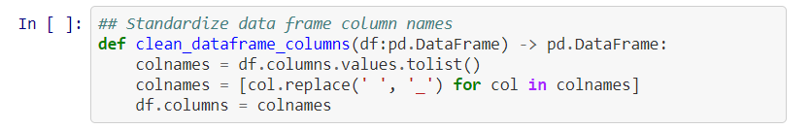

Figure 1.

Following the standardization of the column names was the task of duplicating the courses with multiple sessions. This was done because in the final result, different professors can be teaching the session while the constraint of one professor per course is still being upheld. The computer needed a way to understand that this was possible.

Once the courses with multiple sessions were duplicated, the work to create the preferences list started. One of the tasks specifically listed in the project description was to create a randomly generated list of preferences for each professor according to their qualification. A portion of the code can be seen below in figure 2.

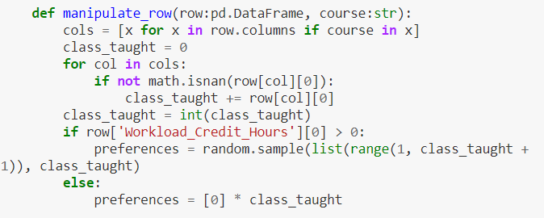

Figure 2.

After the first task listed in the project was completed, it was time to define periods. For the purpose of this project, units of 30 minutes time were created called periods. These existed from 0800 to 1730 every day to assist in the scheduling of classes. Period operated by existing within a designated 30 minutes timeframe. For instance, period one was 0800, period two was 0830 and so on. Once the last period was assigned at 1730, period 20, it was continued onto the next day. Therefore, 0800 on Tuesday would be registered as period 21. This trend continued on from Monday through Friday. The code that accomplished this task is shown below in figure 3.

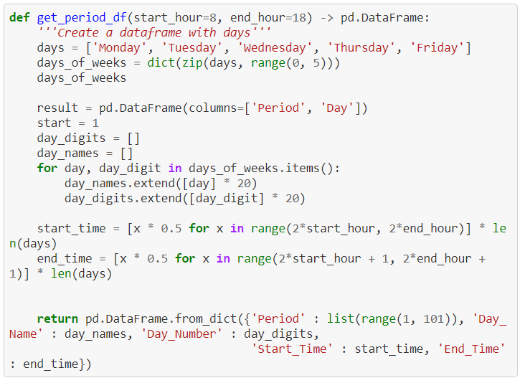

Figure 3.

As listed in the project description, the code should be written in a way that another department can easily replicate the assignment process. The code can be seen below in figure 4.

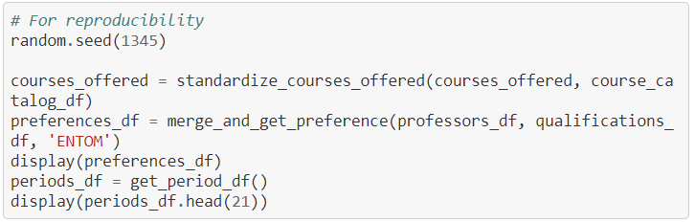

Figure 4.

Once the reporducibilty was created, the team began working on shaping the model. The first step was to create the model environment and decision variable. Once this was completed, the constraint begin. Each constraint was coded after each other. A portion of the code can be seen below in figure 5.

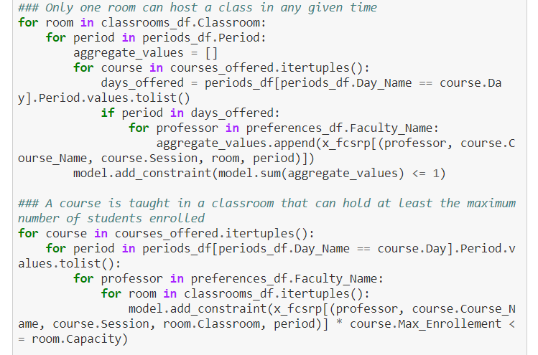

Figure 5.

Once all of the need constraints have been written, the team began coding the two special rules as listen in the project description. The two rules that were created were that senior courses started at 1300 and no classes were taught on Friday after 1600. The code for both of these can be see in figure 6 and 7.

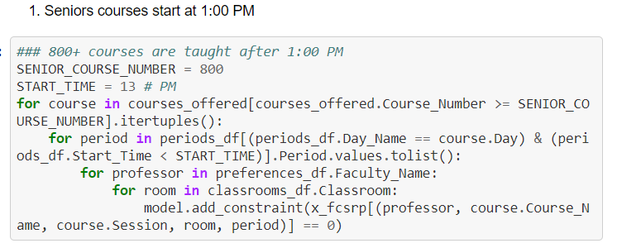

Figure 6

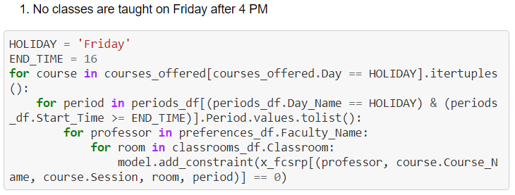

Figure 7.

Once the conrstaints and special rules were made, the next step was to create the objective function. The purpose of this project was to maximize the total preferences of the professors. This code can be seen below in figure 8.

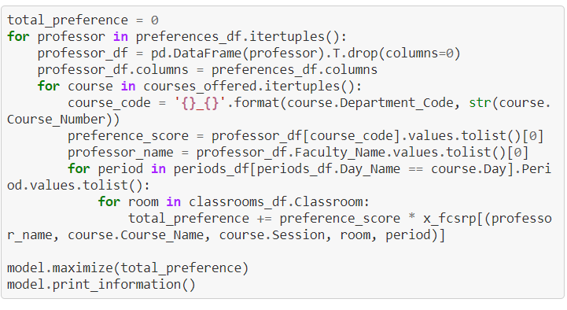

Figure 8.

When the objective function was completed, all that was left was to solve the model and conduct post-processing. Post-processing was done so that the result would be clean and easier to comprehend.

1. **RESULTS**

As stated previously, the desired utput is to maximize the preference list and output a feasible course semester schedule based on that list. As seen in figure 9, this is what has been done.

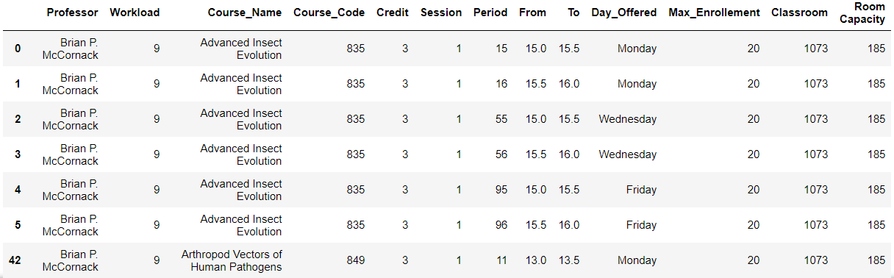

Figure 9.

The results of the code clearly showcase the professors name, their respective workload for the semester, the courses they will be teaching, the sessions of each course, the periods its being taught, the days the class occurs, and lastly the classroom the course is being taught in. All of this information is being presented in the way so that it can be easily understand who is teaching what, when, and where. This system repeats for every professor that has a workload greater than zero, showing the course that the model has assigned them based off of the preference list.

1. **CONCLUSION**

This report showcased a feasible course semester schedule intended to optimize the preference list. The parameters consisted of the department and course information, professor qualifications, and credit hours. The report shows the need for the implementation of this model to easily solve the scheduling problems for the departments within Mavericks University.

Regarding future work, this model can be used within the many departments of Maverick University so long as the data is presented in a similar structure. This model is intended to be used for multiple departments across multiple semesters. If given more time, this model can be fine tuned to provide a result that is more realistic instead of what is the most optimal route.